Title Jurnal Ekonomi Syariah
(The title of the article should be clear (not ambiguous) and identifying the content. The title's format uses Times New Roman 16 Bold, Centered Alignment, and must be Capitalized Each Word. It is one space with 0pt spacing (before) and 12pt spacing (after).

Author^{1*}, Author ²
(Without honorary name or degree and should be written in full name)

The affiliation is written in full name (not abbreviation) and complete address just as the example below:
^{1,2} Islamic Economics Study Program, Faculty of Islamic Economics, Universitas Islam KH. Achmad Muzakki Syah, Indonesia.

ARTICLE HISTORY  Received:  12 June 2024  Revised  15 June 2025  Accepted:  17 June 2025  Online available:  20 June 2025  Keywords (TNR 10):  Keyword a,  Keyword b,  Keyword c,  Keyword d, Keyword-n.  The keywords should be avoiding general and plural terms and multiple concepts. Keywords should not be more than 5 words..  *Correspondence: Name:  E-mail: ……. | ABSTRACT  (Time News Roman 11, UPPERCASE, Bold, 1 spacing)  Introduction: The abstract comes after the title page in the manuscript. Abstract must be integrated and independent which is consist of introduction and clearly stated the purpose of research  Methods: Example, this research is a quantitative study that applies the Johansen Integration Test and Vector Error Correction Model to see the long-term impact and shock response on certain variables.  Results: Report the main outcome(s)/findings including (where relevant) levels of statistical. Example, the findings indicate the existence of short-term and long-term causality between macroeconomic variables and the Indonesian Islamic stock index. Especially in the long run, industrial production index and inflation have a significant effect on ISSI, while the exchange rate, interest rates and SBIS have no significant effect on ISSI  Conclusion and suggestion: Should relate to the study aims and hypotheses. However, the abstract should be written as a single paragraph without these headers. For this reason, references should be avoided. Also, non-standard or uncommon abbreviations should be avoided, but if essential they must be defined at their first mention in the abstract itself. Abstract must be written using 150 until 250 words which have no reference and accompanying keywords. (TNR 11, justify, 1 spacing)

Cite this document: APA 11th edition
Alfian, E. Izzat. (2025). Kajian Komunikasi pemasaran terpadu dalam mendorong keputusan pembelian jasa perbankan. Lan Tabur: Jurnal Ekonomi Syariah, 7 (1), 1-17.
https://doi.org/10.53515/lt.v5i2.114

- Introduction
The introduction contains research background, brief description of literature review from previous researches (State of the art) to show the limitation of previous research, the expected goals, the renewal of reseach. It is in Times New Roman 12. Unlike research report, the literature review should be in the form of previous studies (state of the art) to show the renewal of the scientific article.

- Literature Review
The literature review contains descriptions of theories, findings and other research materials obtained from the reference materials used as the basis of the research.

- Methodology
It contains the research design, population, sample, data collection and analysis techniques, in Times New Roman 12. There is no need to present research methods for conceptual articles/literature studies, only Literature Reviews, results and discussion immediately after the introduction.

- Results And Discussion
The result of the article contains the data analysis written descriptively using Times New Roman 12. Tables and figures in each article is three (3) at most, B&W, not colorful. Discussion presents each of the findings compared to relevant theories or previous studies, actual facts, comments, and reasonable analysis from researchers.
The utilization of sub-chapter in discussion corresponds to the needs of discussion.

For instance:
Sub Chapter 1 (Times New Roman 12, bold)
Sub Sub Chapter 1
Sub Sub Chapter 2
Sub Chapter 2 (Times New Roman 12, bold)
Sub Sub Chapter 1
Sub Sub Chapter 2
Sub Chapter 3 (Times New Roman 12, bold)
Sub Sub Chapter 1
Sub Sub Chapter 2

Tables and figures should be incorporated in the text as close to the reference as possible and should be in a form suitable for publication when printed with a good quality laser printer. Figures will be printed in black and white and should be readily interpreted without the use of color. Tables and figures may extend across both columns. Captions should be Times New Roman 11-point, centered. Tables and pictures should be sequentially numbered in separate series. Captions for tables should be above the table. Captions for figures should be below the figure. Tables contains primary source should not be captioned.

Figure

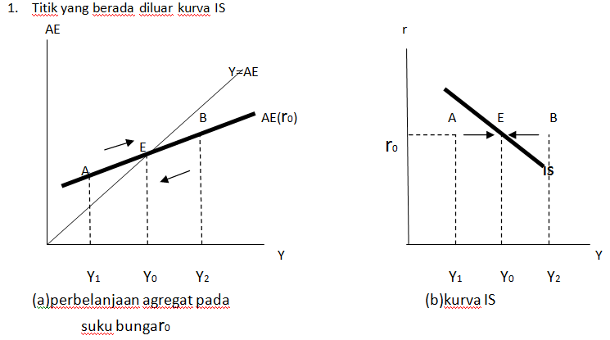

Figure 1. IS Curve

Tables

Table 1. The Growth of Islamic Banks and Conventional Banks Number Year 2013 – 2017
Group of Banks | 2013 | 2014 | 2015 | 2016 | 2017
Islamic Banks | 11 | 12 | 12 | 13 | 13
Conventional Banks | 120 | 119 | 118 | 116 | 115
Islamic Business Units | 23 | 22 | 22 | 21 | 21
Islamic Rural Banks | 163 | 163 | 163 | 166 | 167
Source: Indonesia Banking Statistics (2013-2017)
Mathematical Formula
Mathematical formulas should be numbered and clearly presented using Microsoft Equation:
$f\left(x\right)=a_{0}+\sum_{n=1}^{∞}{}\left(a_{n}+b_{n}sinsin \frac{nπx}{L} \right)$ (1)

- Conclusion
It contains a conclusion and suggestion. The conclusion briefly illustrates the results that address the hypotheses and research purposes or findings. The summary of the research and discussion relevant to the findings, presented descriptively, not numeric. Suggestion provides things expected to conduct related to further ideas the research has proposed.

Author contribution statement
CRediT (Contributor Roles Taxonomy) was introduced with the intention of recognizing individual author contributions, reducing authorship disputes and facilitating collaboration.

Acknowledgements
These people who need to be mentioned in the Acknowledgments section are those who have assisted in the research process and the preparation of the article. Most academic papers have people who have helped in some way in the preparation of the written version or the research itself. It can be from sponsoring institutions, donor agencies, other researchers, or even family, friends or colleagues who have helped in the preparation.

References
Every text source should be listed in reference, and the references are included in the body of the text. All sources appearing in the reference list must be ordered alphabetically by surname. It should contain reference literature from primary resources (e.g., the scientific journal with DOI), and at least 80% of them are published in the last 10 (ten) years. Each of the articles should have at least 20 references. It is suggested to use a reference manager (e.g., Mendeley, Zotero, RefWorks, Endnote, etc.) to write the text and citation. The format of writing the references uses APA 7th edition (American Psychological Association). All citations must be hyperlinked with references. For help, see this video https://youtu.be/p9YRwyQdWWI

Information:
Lan Tabur: Jurnal Ekonomi Syariah template changed for the better since vol. 7 no 1 in 2025

